Ideation Phase
Empathize & Discover

Date | 31 January 2025
Team ID | LTVIP2026TMIDS82222
Project Name | HouseHunt – Finding Your Perfect Rental Home
Maximum Marks | 4 Marks

Empathy Map Canvas:
Target User: Renter (Primary User – Alice)
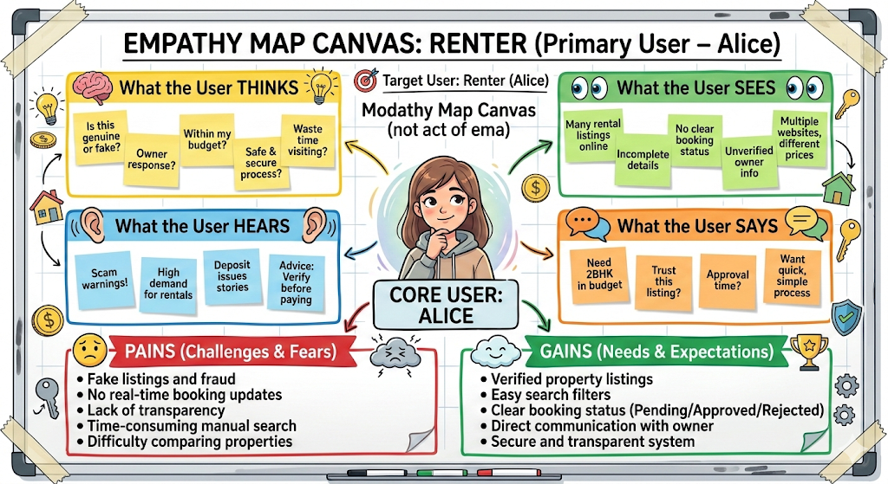

Secondary Empathy Map – Property Owner (Bob)
